1. 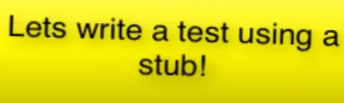
2. **Agenda**:
   1. <https://github.com/in28minutes/MockitoTutorialForBeginners/blob/master/Step03.md>
   2. 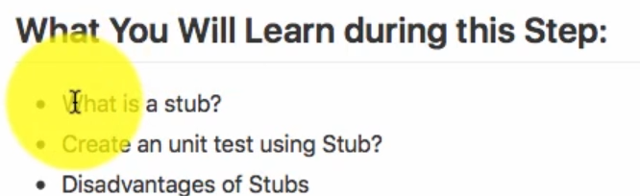
3. **Stub**: Stub is nothing but a sample implementation to return sample data. Such as in our case for TodoService.java which is an interface.
4. 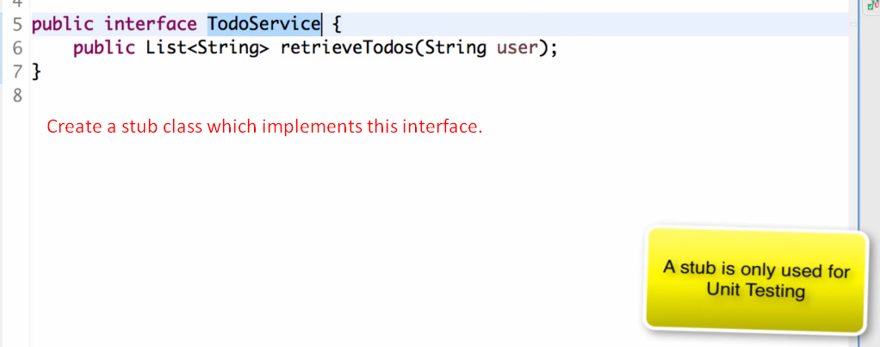
5. 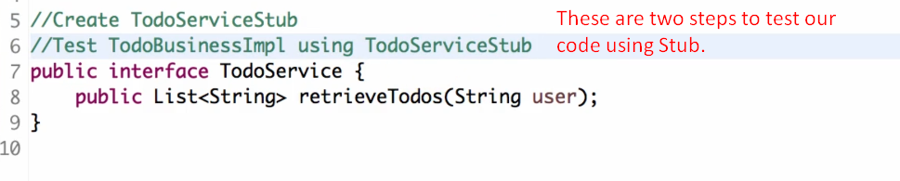
6. 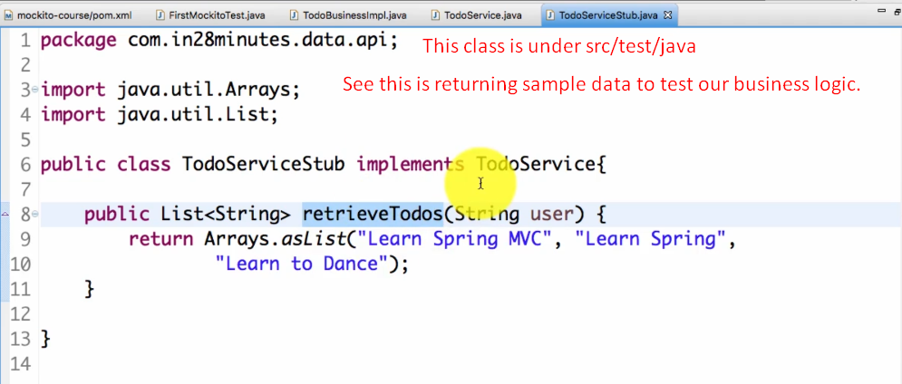
7. 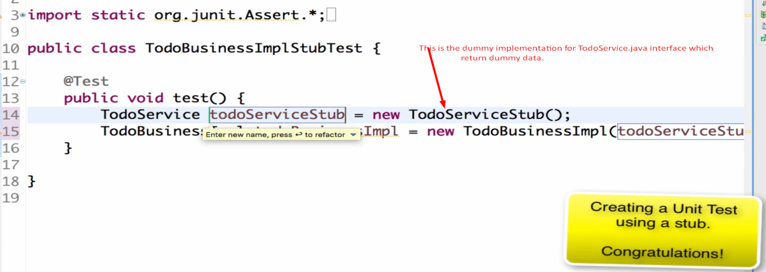
8. 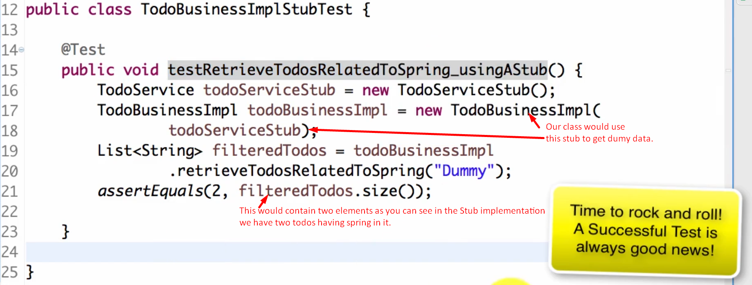
9. 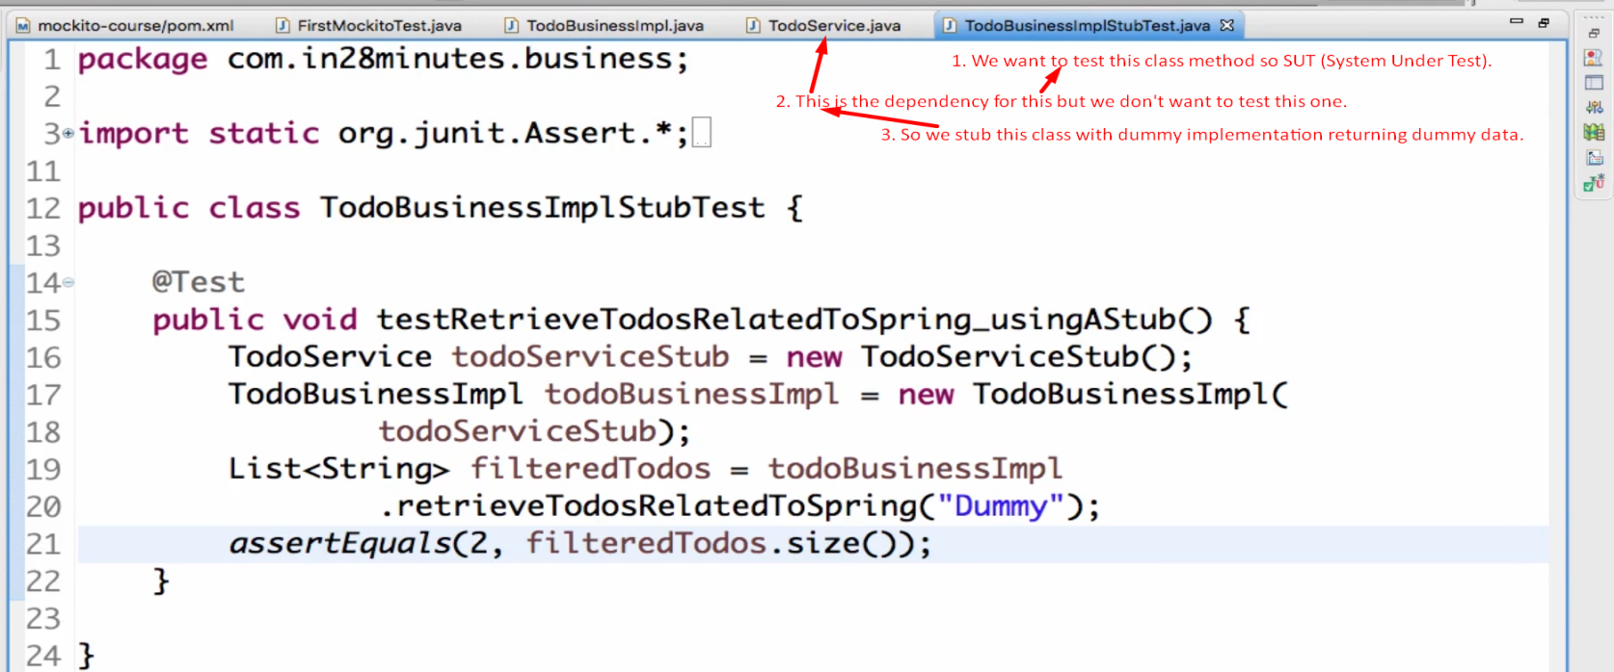
10. 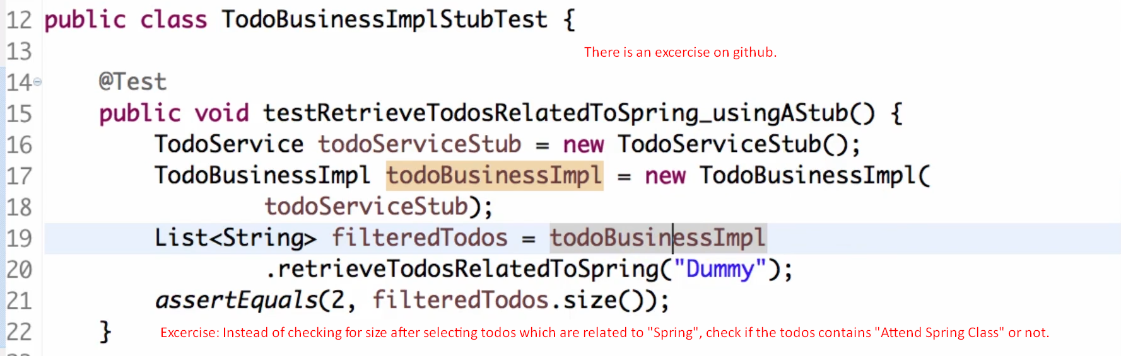  
    But we’re not focusing on the exercise for stubs but on what is advantages and dis-advantages of stubs.

Let’s talk about disadvantages of stub

1. 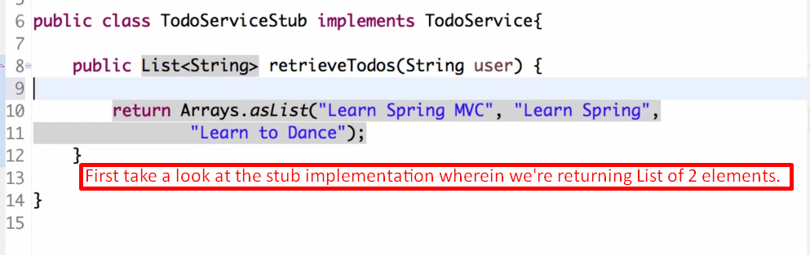
2. 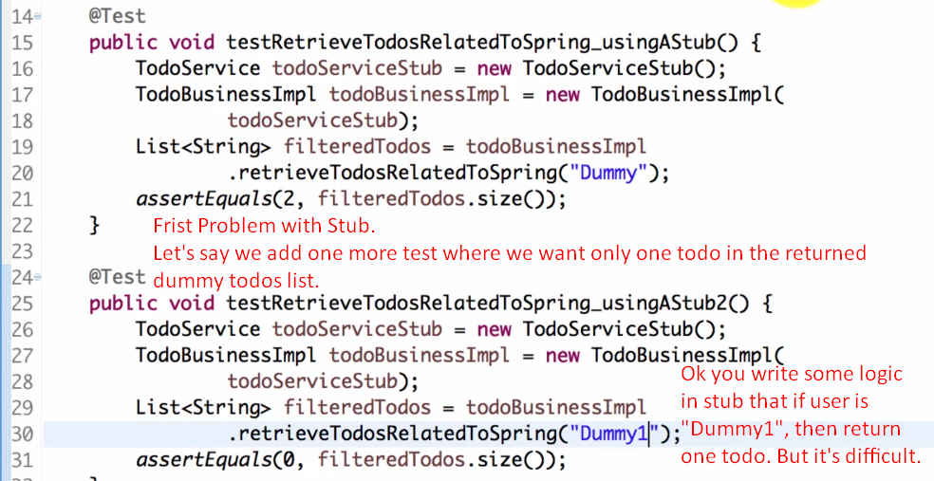
3. 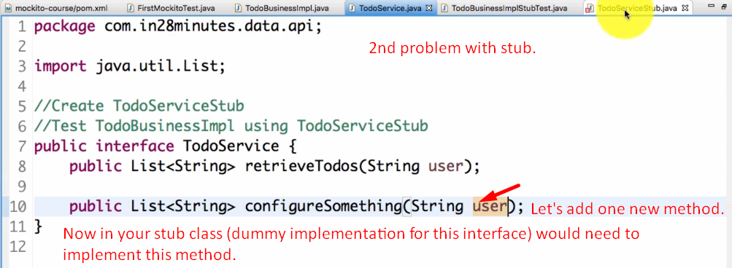
4. 